Linux Servers Monitoring using Grafana, Prometheus, and Node Exporter

Prometheus

Create Prometheus User and Directories
- Create a system user for Prometheus without login access and sets up configuration and data directories.

useradd --no-create-home --shell /bin/false prometheus
mkdir -p /etc/prometheus /var/lib/prometheus

Set Permissions
- Gives ownership of Prometheus directories to the Prometheus user for proper access control.

chown -R prometheus:prometheus /etc/prometheus /var/lib/prometheus

Download and Extract Prometheus
- Downloads the latest Prometheus binary and extracts it for installation.

wget https://github.com/prometheus/prometheus/releases/download/v3.7.3/prometheus-3.7.3.linux-amd64.tar.gz
tar -xvf prometheus-3.7.3.linux-amd64.tar.gz

Move Prometheus Binaries
- Moves Prometheus executables to the system path for global access and assigns ownership.

mv prometheus promtool /usr/local/bin
chown prometheus:prometheus /usr/local/bin/prometheus /usr/local/bin/promtool

Move Configuration Files
- Moves configuration and console files to the Prometheus config directory with proper permissions.

mv prometheus.yml /etc/prometheus/
mv consoles console_libraries /etc/prometheus/
chown -R prometheus:prometheus /etc/prometheus/

Configure Prometheus
Edit the configuration file:
vim /etc/prometheus/prometheus.yml

Sample Configuration:
global:
scrape_interval: 10s
scrape_configs:
- job_name: 'prometheus_master'
scrape_interval: 5s
static_configs:
- targets: ['localhost:9090']

Create Systemd Service File
- Creates a service to automatically start Prometheus on system boot.

vim /etc/systemd/system/prometheus.service

Service Configuration:
[Unit]
Description=Prometheus Monitoring System
Wants=network-online.target
After=network-online.target
[Service]
User=prometheus
Group=prometheus
Type=simple
ExecStart=/usr/local/bin/prometheus \
--config.file=/etc/prometheus/prometheus.yml \
--storage.tsdb.path=/var/lib/prometheus/ \
--web.console.templates=/etc/prometheus/consoles \
--web.console.libraries=/etc/prometheus/console_libraries
[Install]
WantedBy=multi-user.target

Enable and Start Prometheus
- Reloads systemd, enables Prometheus service, and verifies its running status.

systemctl daemon-reload
systemctl enable --now prometheus
systemctl status prometheus

Access Prometheus Web Interface
- Open Prometheus dashboard in a browser to verify installation.

http://<server_IP>:9090

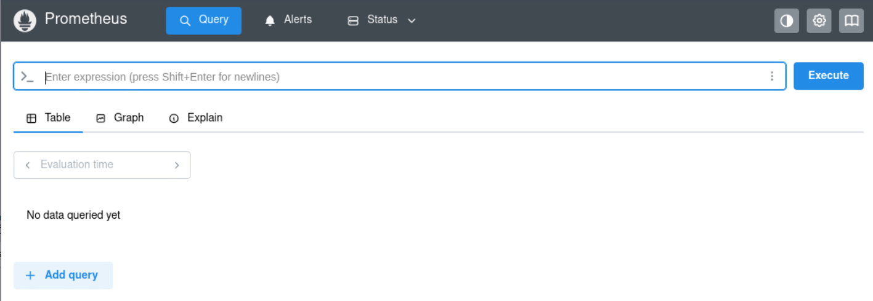

Install Node Exporter
- Downloads and runs Node Exporter to collect system metrics such as CPU, memory, and disk usage.

wget https://github.com/prometheus/node_exporter/releases/download/v1.10.2/node_exporter-1.10.2.linux-amd64.tar.gz
tar -xvf node_exporter-1.10.2.linux-amd64.tar.gz
cd node_exporter-1.10.2.linux-amd64
./node_exporter

Verify Node Exporter
- View raw system metrics exposed by Node Exporter.

http://localhost:9100/metrics

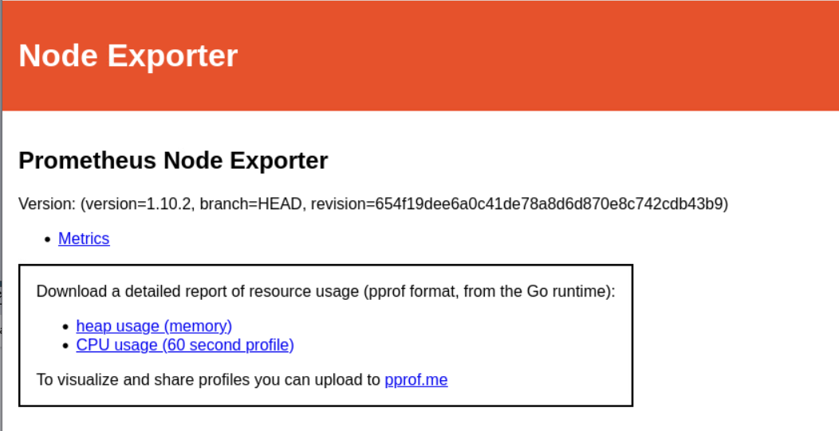

Add Node Exporter to Prometheus Configuration
Edit Prometheus config:

vim /etc/prometheus/prometheus.yml

Add the Node Exporter target:
scrape_configs:
- job_name: 'node'
static_configs:
- targets: ['localhost:9100']

Restart Prometheus
- Applies the new configuration and starts collecting node metrics.

systemctl restart prometheus

Verify Targets in Prometheus
- Check that both Prometheus and Node Exporter targets are listed and active.

http://localhost:9090/targets

Grafana

Install Grafana (Dashboard Visualization Tool)
- Imports Grafana’s GPG key for package verification.

wget -q -O gpg.key https://rpm.grafana.com/gpg.key
sudo rpm --import gpg.key

Configure Grafana Repository
- Adds Grafana repository for installation via DNF.

vim /etc/yum.repos.d/grafana.repo

Repo File:
[grafana]
name=Grafana
baseurl=https://rpm.grafana.com
repo_gpgcheck=1
enabled=1
gpgcheck=1
gpgkey=https://rpm.grafana.com/gpg.key
sslverify=1
sslcacert=/etc/pki/tls/certs/ca-bundle.crt

Install and Start Grafana
- Installs Grafana and enables it to start automatically on boot.

sudo dnf install grafana -y
sudo systemctl enable --now grafana-server

Access Grafana Web Interface
- Log in to Grafana and connect Prometheus as a data source to create dashboards.
http://<server_IP>:3000
Default Credentials:
- Username: admin
- Password: admin
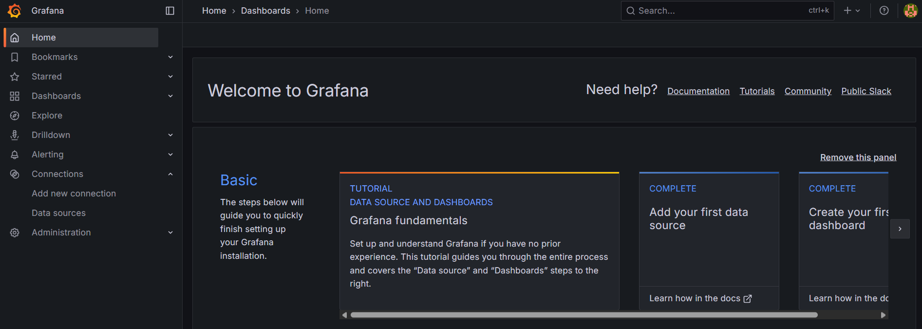

- This is a Grafana dashboard connected to Prometheus and Node Exporter, showing system performance metrics for your monitored machine (prometheus.example.lab).
